**6.Raspberry Pi platform -------** **tracking**

**1)****Preparation**

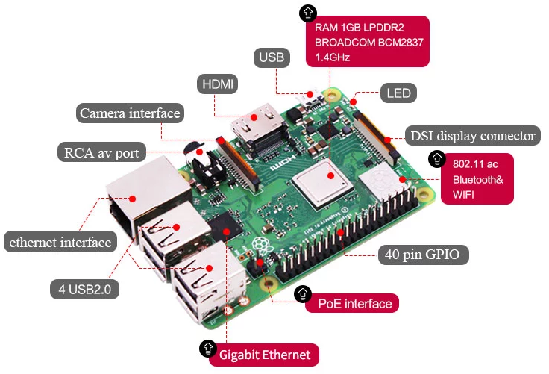

1-1 Raspberry Pi board

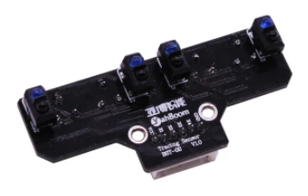

1-2 Infrared patrol module

**2)Purpose of Experimental**

After running the tracking executable in the Raspberry Pi system, you need to press the K2 to start the car, and the tracking function is started. The robot car will automatically walk along the black line.

**3)Principle of experimental**

The basic principle of the infrared tracking sensor is to take advantage of the reflective nature of the object. In this experiment, we need the effect that the robot car walk along the black line. When the infrared light is emitted onto the black line, it will be absorbed by the black line, but when the infrared light is emitted onto the other colors line, it will be reflected onto the infrared receiver pin. According to this, we write the corresponding code to make the car complete tracking function.

When the car detects the black line, the indicator status of the infrared tracking module is as shown in the figure below.

(Note:The TrikeBot car controls the direction of the front rubber wheel by controlling the servo. In this way, the direction of the car is controlled. In this experimental, we set the angle of the servo to 55 degrees according to the actual situation, indicating that the car is in the front. We set the angle of the servo to 110 degrees according to the actual situation, indicating that the car is turning left. We set the angle of the servo to 0 degrees according to the actual situation, indicating that the car is turning right.)

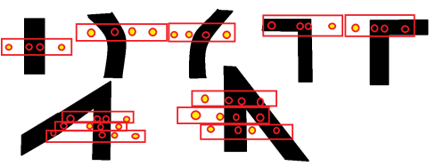

**4)Experimental Steps**

4-1 About the schematic

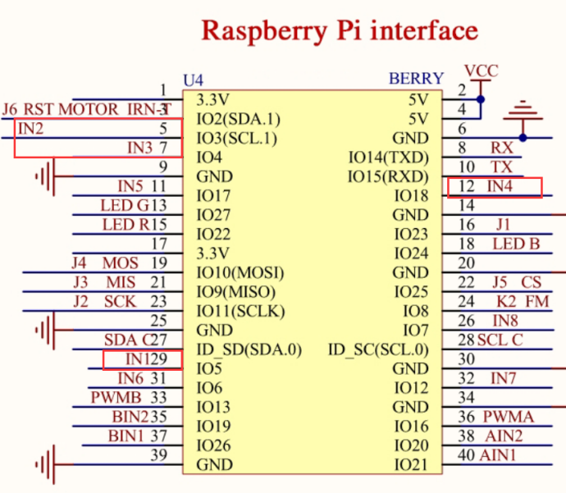

4-1 Raspberry Pi interface circuit diagram

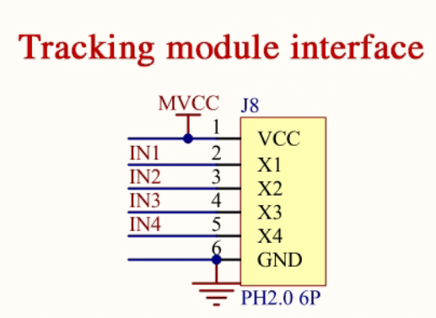

4-2 Tracking module interface

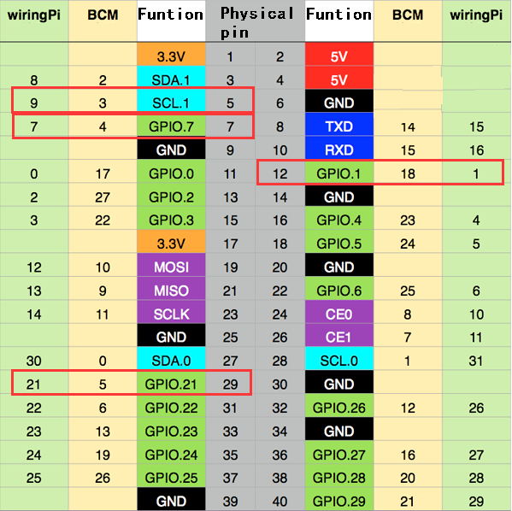

4-3 Raspberry Pi 40 pins comparison table

4-2 According to the circuit schematic:

Left1 infrared sensor-----5(Physical pin)----- 9(wiringPi)

Left2 infrared sensor-----29(Physical pin)----- 21(wiringPi)

Right1 infrared sensor-----7(Physical pin)----- 7(wiringPi)

Right2 infrared sensor-----12(Physical pin)----- 1(wiringPi)

(Note: We use the wiringPi library to write code.)

(Note: In this experiment, we can adjust the sensitivity of the tracking module by rotating the potentiometer of the infrared tracking module to achieve better experimental results.)

4-3 About the code

1. We need to compile this file in the Raspberry Pi system. (Note: we need to add -lwiringPi to the library file.)

We need to input:gcc tracking.c -o tracking -lwiringPi

(2)We need to run the compiled executable file in the Raspberry Pi system.We need to input: ./tracking

(3)We can input: ctrl+c to stop this process, which mean is send a signal to the linux kernel to terminate the current process, but the state of the relevant pin is uncertain at this time, we also need to run a script to initialize all pins.

(Note:The initpin.sh script file is included in the SmartCar directory.)

You need to input:  chmod 777 initpin.sh

./initpin.sh

As shown in the figure below.

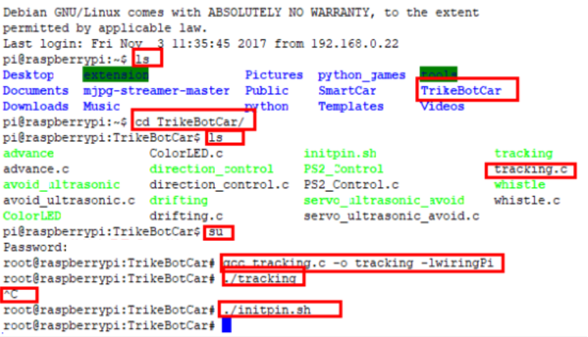

After completing the above steps, the experiment is over.